Project Report
On

Interactive Web Applications Development
Submitted
In partial Fulfilment of
Bachelor of Computer Application-BCA(DS&BDA)
MANAV RACHNA INTERNATIONAL INSTITUTE OF RESEARCH AND STUDIES
Submitted by:
Student name | Hardik Linzara
Roll number | 23/SCA/BCA(DS&BDA)/013
Programme | BCA (DS-BDA)
Section | BCA 5thE
Under the Supervision of:
Name | Mr. Devan Chopra
Designation | Software Development Manager
 SCHOOL OF COMPUTER APPLICATIONS [ Sector-43, Aravalli Hills (Faridabad-121001)]
Declaration

I do here by declare that this project work entitled "Web Development Projects: Internship Report at Prodigy Infotech"submitted by me for the partial fulfillment of the requirement for the award of Bachelor of Computer Application-BCA(DS&BDA) is a record of my own work. The report embodies the findings based on my study and observation and has not been submitted earlier for the award of any degree or diploma to any Institute or University.

SIGNATURE
Name: Hardik Linzara
Roll No: 23/SCA/BCA(DS&BDA)/013

Certificate from the Guide

This is to certify that the project report entitled "Web Development” submitted in partial fulfillment of the degree of Bachelor of Computer Application-BCA(DS&BDA) to Manav Rachna International Institute of Research and Studies, Faridabad is carried out by

Mr. Hardik Linzara (Roll No), 23/SCA/BCA(DS&BDA)/013 Under my guidance.



Signature of the Guide
Name: Mr. Devan Chopra

Acknowledgement

I gratefully acknowledge the assistance, cooperation, guidance and clarification provided by Mr. Devan Chopra during the development of Web Development projects.
My extreme gratitude to Dr. Raj Kumar, Associate Professor & TPO, who guided us throughout the project. Without his willing disposition, spirit of accommodation, frankness, timely clarification, and above all faith in us, this project could not have been completed in due course. His readiness to discuss all important matters at work deserves special attention.
I would like to extend my sincere gratitude t prof. (Dr.) Suhail Javed Quraishi – HOD, prof. (Dr.) Rashmi Agrawal – Associate Dean and Prof. (Dr.) Brijesh Kumar – Dean for their valuable teachings and advice. I want to thank all the department faculty members for their cooperation and support. I want to thank the non-teaching staff of the department for their cooperation and support.
This opportunity is a big milestone in my career development. I will strive to use gained skills and knowledge in the best possible way, and I will continue to work on their improvement, to attain desired career objectives. I hope to continue cooperating with all of you in the future.

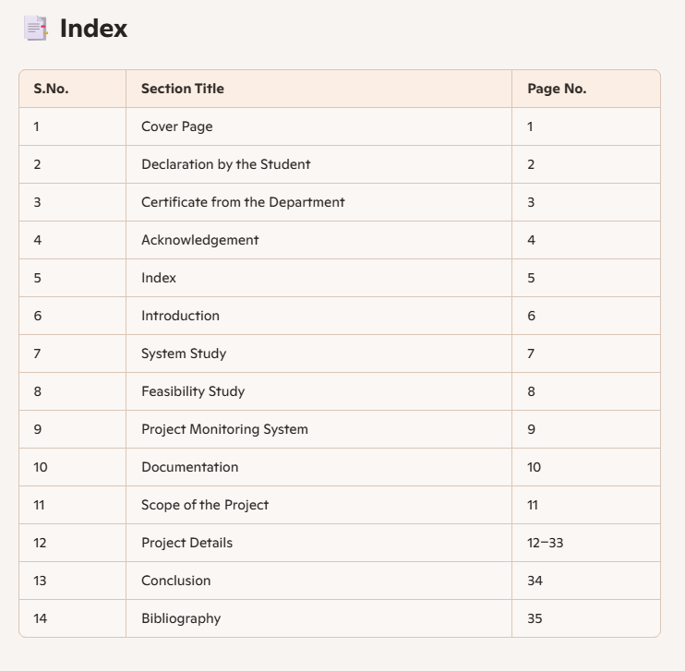

💼 Introduction
- About Organization: Prodigy Infotech is a dynamic and innovative organization committed to nurturing talent and empowering learners with practical and industry-relevant knowledge. Known for its quality training programs, internships, and hands-on learning experiences, Prodigy Infotech bridges the gap between academic education and professional industry standards.
The company offers a wide range of programs in fields such as web development, data science, machine learning, artificial intelligence, and cybersecurity. These programs are designed to help students and early-career professionals build a strong foundation in technical skills through real-world projects and mentorship from industry experts.
With a mission to develop future-ready professionals, Prodigy Infotech provides a platform where learners can gain exposure to current technologies, develop portfolio-worthy projects, and enhance their employability in a competitive job market.
Whether through its virtual internships or interactive workshops, Prodigy Infotech continues to inspire innovation, creativity, and excellence in the tech education space.

- Aims & Objectives: To gain practical knowledge and industry exposure through a virtual internship program offered by Prodigy Infotech, enhancing technical skills and real-world problem-solving abilities in the chosen domain.

- Manpower: The manpower involved in the internship program at Prodigy Infotech includes a blend of professionals, mentors, and interns, working collaboratively in a virtual environment to ensure effective learning and project development.

1. Internship Coordinator / Program Manager
- Responsible for overseeing the internship program.
- Ensures smooth communication between interns and mentors.
- Provides schedules, task details, and evaluation criteria.

2. Industry Mentors / Technical Experts
- Professionals with expertise in relevant fields such as web development, data science, AI, or cybersecurity.
- Guide interns through technical challenges and project work.
- Conduct reviews, offer feedback, and share industry insights.

3. Interns (Students)
- Individuals participating in the internship from various academic backgrounds.
- Work on assigned tasks and real-time projects to enhance technical and professional skills.
- Collaborate in a virtual environment using tools like Google Meet, GitHub, and Trello.

4. Support Staff (Optional/Occasional)
- Handle administrative or technical issues related to the platform, communication tools, or project submissions.

System Study
- Existing System: Manual execution of tasks (e.g. timekeeping, weather checks, game playing) lacked interactive digital solutions.

- Proposed System: Web applications that automate tasks, improve user experience, and showcase modern UI/UX concepts.

📊 Feasibility Study
- Technical: All apps built using HTML, CSS, JavaScript — easily deployable.

- Behavioral: Users engage positively with interactive UI features.

- Economic: Projects developed using free open-source tools.

📘 Documentation
Each project is documented with:
- Objectives and features

- Technologies used

- Code samples

- Flowcharts and diagrams

- Screenshots of UI

- Testing details

- Challenges and outcomes

- Skills developed and conclusion

🌐 Scope of the Project
The scope of this project goes beyond completing basic functionality. It lays the foundation for future development and enhancements in both technical depth and user experience. These projects can be scaled, optimized, and integrated with emerging technologies, making them suitable for real-world applications and portfolio building.

Future Possibilities and Enhancements:
- Backend Integration and Database Support
  - Add user authentication and profile management using Node.js, Django, or Flask.
  - Store and retrieve user data, project tasks, weather preferences, and stopwatch records in real-time using databases like MySQL, MongoDB, or Firebase.
  - Enable personalized experiences based on user inputs and activity history.
- Cloud Hosting and Deployment
  - Host the portfolio website and weather applications on platforms such as GitHub Pages, Vercel, Netlify, or AWS.
  - Enable global access and improve reliability by using cloud hosting and CDN (Content Delivery Network) services.
  - Implement CI/CD pipelines for smooth version control and auto-deployment.
- Machine Learning and AI Integration
  - Use AI predictions for the stopwatch (e.g., predicting lap times based on previous data).
  - Build an AI-powered Tic-Tac-Toe opponent using the Minimax algorithm or Reinforcement Learning.
  - Add a recommendation system to suggest projects or technologies based on user skill levels and interests.
- Responsive and Accessible UI/UX Design
  - Improve mobile, tablet, and desktop compatibility with responsive design frameworks like Bootstrap or Tailwind CSS.
  - Ensure accessibility (a11y) by following WCAG guidelines (keyboard navigation, screen reader support).
  - Add dark/light themes and animation for a more dynamic user interface.
- API Integrations
Use third-party APIs for more accurate weather data, geolocation, or even project updates from GitHub.

Project 1: Responsive Landing Page

🔍 Objective
To develop a visually appealing and interactive landing page with a fixed navigation menu that dynamically responds to user actions like scrolling and hovering.

🛠 Technologies Used
- HTML5
- CSS3
- JavaScript

💡 Key Contributions
- Created structured HTML layout with semantic tags
- Implemented responsive CSS design compatible with multiple screen sizes
- Developed JavaScript functions for scroll-triggered and hover-triggered style changes
- Ensured fixed positioning of the menu across all viewports

⚔️ Challenges Faced
- Managing responsiveness across different browser types
- Fine-tuning animation transitions for smooth user experience
- Debugging overlapping styles between CSS and JS-generated events

🎯 Outcomes
- A polished, scroll-reactive landing page was produced
- Enabled users to navigate seamlessly with a stylish and fixed top menu
- Demonstrated adaptive UI design under dynamic user actions

🔧 Skills Developed

📟 Technical Skills
- DOM manipulation using JavaScript
- Responsive design principles with CSS Grid/Flexbox
- Debugging web interactions and browser console issues

🗣️ Soft Skills
- Time management during multiple prototype iterations
- Handling feedback from peer reviews and refining design

🤝 Teamwork and Collaboration
- Participated in weekly check-ins with mentors
- Incorporated suggestions from peer interns for UI consistency

📝 Conclusion

🧭 Summary of Internship Experience
This project was a strong foundational exercise in user-focused web design. It shaped my understanding of how digital interfaces respond to user input and behavior.

✍️ Personal Reflections
Crafting something visually dynamic made me appreciate the subtle complexities of front-end development. Every scroll and hover is a chance to delight a user.

🌟 Future Aspirations
I aim to deepen my knowledge in animation libraries like GSAP and frameworks like React to elevate user interface dynamics even further.

Appendices

💬 Code Snippets
html
<nav class="fixed-menu">...</nav>
javascript
window.addEventListener("scroll", function() {
document.querySelector(".fixed-menu").classList.toggle("scrolled", window.scrollY > 50);
});

📈 Diagrams
Blueprint of landing page layout:
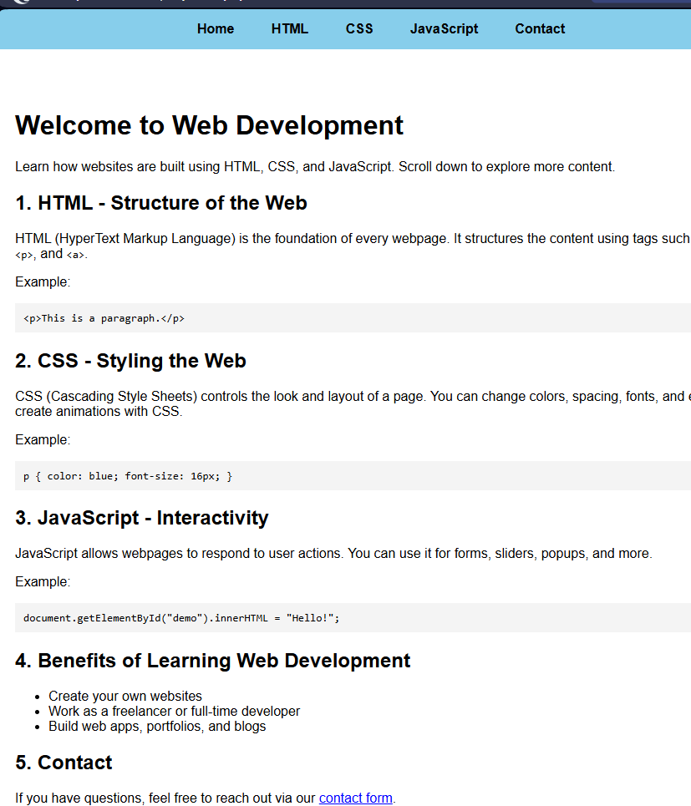
📚 References
- Mozilla Developer Network: HTML & JavaScript
- CSS Tricks
- W3Schools: Responsive Design Principles

🕒 Project 2: Stopwatch Web Application

🔍 Objective
To design and implement a browser-based stopwatch that enables users to track time, manage laps, pause, and reset—all through a clean, responsive interface.

🛠 Technologies Used
- HTML
- CSS
- JavaScript

💡 Key Contributions
- Built a modular structure for stopwatch features using vanilla JavaScript
- Enabled accurate time calculation and display using setInterval()
- Designed user-friendly control buttons for start, pause, reset, and lap
- Provided a sleek interface with responsive layout elements

⚔️ Challenges Faced
- Synchronizing timing logic across pause and resume functions
- Ensuring consistent lap recording and storage
- Managing responsive display across various screen dimensions

🎯 Outcomes
- A reliable, browser-friendly stopwatch application
- Lap feature added for interval tracking during activity
- Demonstrated logic building and event handling in JavaScript

🔧 Skills Developed

📟 Technical Skills
- Time tracking implementation using JavaScript intervals
- Dynamic DOM updates for real-time UI changes
- Responsive and accessible web design practices

🗣️ Soft Skills
- Precision handling for interactive event flows
- Debugging time-sensitive features in real-time applications

🤝 Teamwork and Collaboration
- Collaborated with peers to cross-test functionality
- Incorporated improvements from mentor feedback on performance issues

📝 Conclusion

🧭 Summary of Internship Experience
This project sharpened my core JavaScript skills and introduced me to the complexity of real-time user interactions within the browser environment.

✍️ Personal Reflections
Timekeeping seems simple—until you're building it from scratch! Every millisecond counts and I learned how browsers treat timing and performance.

🌟 Future Aspirations
I’m motivated to explore advanced JavaScript libraries like RxJS for time-based programming and maybe mobile app development using React Native.

📎 Appendices

💬 Code Snippets
javascript
let startTime, updatedTime, difference, timerInterval;
function startTimer() {
startTime = new Date().getTime();
timerInterval = setInterval(updateTime, 1000);
}

📈 Diagrams
User flow diagram for stopwatch controls:
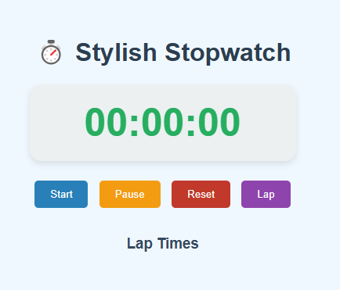
📚 References
- JavaScript.info
- MDN Web Docs: setInterval() and Date API
- CSS Tricks

🎮 Project 3: Tic-Tac-Toe Web Application

🔍 Objective
To build an interactive tic-tac-toe game that allows two players (or one vs AI) to compete on a 3×3 grid, with functionality for turn-based play and win detection.

🛠 Technologies Used
- HTML5
- CSS3
- JavaScript

💡 Key Contributions
- Constructed game board layout using HTML table/grid
- Designed game logic for move validation, win conditions, and draw handling
- Implemented real-time user interaction with click-based turns
- Added reset feature to replay matches

⚔️ Challenges Faced
- Designing an intuitive algorithm for win checking in multiple directions
- Handling edge cases like double-clicks or incorrect moves
- Balancing gameplay logic for future AI implementation

🎯 Outcomes
- Functional browser-based game with clear visual feedbackSmooth transitions between turns, win/draw alerts, and board resets
- Strengthened logic-based programming skills

🔧 Skills Developed

📟 Technical Skills
- Game state management using arrays and loops
- Conditional logic for win/draw tracking
- Dynamic DOM manipulation for real-time feedback

🗣️ Soft Skills
- Focus and attention to algorithmic accuracy
- Refining user interface through iterative design feedback

🤝 Teamwork and Collaboration
- Peer review sessions to playtest and debug game flow
- Discussed enhancement ideas with mentors for AI opponent integration

📝 Conclusion

🧭 Summary of Internship Experience
This playful project helped me explore JavaScript's power for controlling logic, handling events, and making decisions within dynamic applications.

✍️ Personal Reflections
I never knew coding a simple game could sharpen my problem-solving skills this much. Every possible winning path demanded careful thought!

🌟 Future Aspirations
I’d love to introduce minimax algorithms to create a smart AI opponent, and maybe port it to mobile as a React Native game.

📎 Appendices

💬 Code Snippets
javascript
function checkWin(board) {
// Rows, columns, diagonals — check for same marker
}

html
<table>
<tr>
<td onclick="playMove(this, 0)"></td>
...
</tr>
</table>

📈 Diagrams
Game flowchart: Start → Player 1 Turn → Player 2 Turn → Check Win → Declare Result
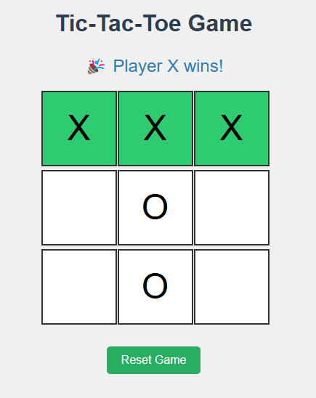

📚 References
- MDN Web Docs: DOM Events
- JavaScript.info: Array methods & logic
- FreeCodeCamp: Building Tic-Tac-Toe tutorials

🖼️ Project 4: Personal Portfolio Website

🔍 Objective
To create a personal portfolio website that showcases professional background, skills, projects, and achievements with an engaging and modern design.

🛠 Technologies Used
- HTML
- CSS
- JavaScript

💡 Key Contributions
- Designed responsive layout using CSS Flexbox and Grid
- Integrated multiple sections: Home, About Me, Projects, Contact
- Embedded professional photograph and descriptive content
- Implemented interactive elements like smooth scrolling and animations

⚔️ Challenges Faced
- Achieving cross-browser compatibility for layout and animations
- Crafting compelling personal content that reflects personality and professionalism
- Organizing multiple sections in a cohesive design

🎯 Outcomes
- Created a fully functional website that serves as a digital resume and portfolio
- Optimized for mobile and desktop devices
- Developed visually clean and informative content flow

🔧 Skills Developed

📟 Technical Skills
- Responsive web design using Flexbox, Grid, and Media Queries
- Clean and semantic HTML structuring for SEO optimization
- UI/UX design principles applied to navigation and user flow

🗣️ Soft Skills
- Self-presentation through professional writing and layout
- Visual storytelling to communicate strengths and experiences

🤝 Teamwork and Collaboration
- Collaborated with peers for review and content proofreading
- Integrated feedback from mentors on design layout and usability

📝 Conclusion

🧭 Summary of Internship Experience
This project taught me the essentials of presenting myself professionally through design and interactivity. It combined technical execution with personal storytelling.

✍️ Personal Reflections
Building a site that reflects “me” was surprisingly introspective. Every section—from skills to contact—was a chance to define my growth and aspirations.

🌟 Future Aspirations
I plan to keep enhancing this portfolio by adding new projects, integrating CMS like WordPress, and connecting it to a custom domain for broader reach.

📎 Appendices

💬 Code Snippets
html
<section id="about-me">
<h2>About Me</h2>
<p>Web developer with a passion for building sleek user interfaces...</p>
</section>
css
#about-me {
display: flex;
align-items: center;
padding: 20px;
}

📈 Diagrams
Website wireframe: Navigation → Banner → About → Projects → Contact
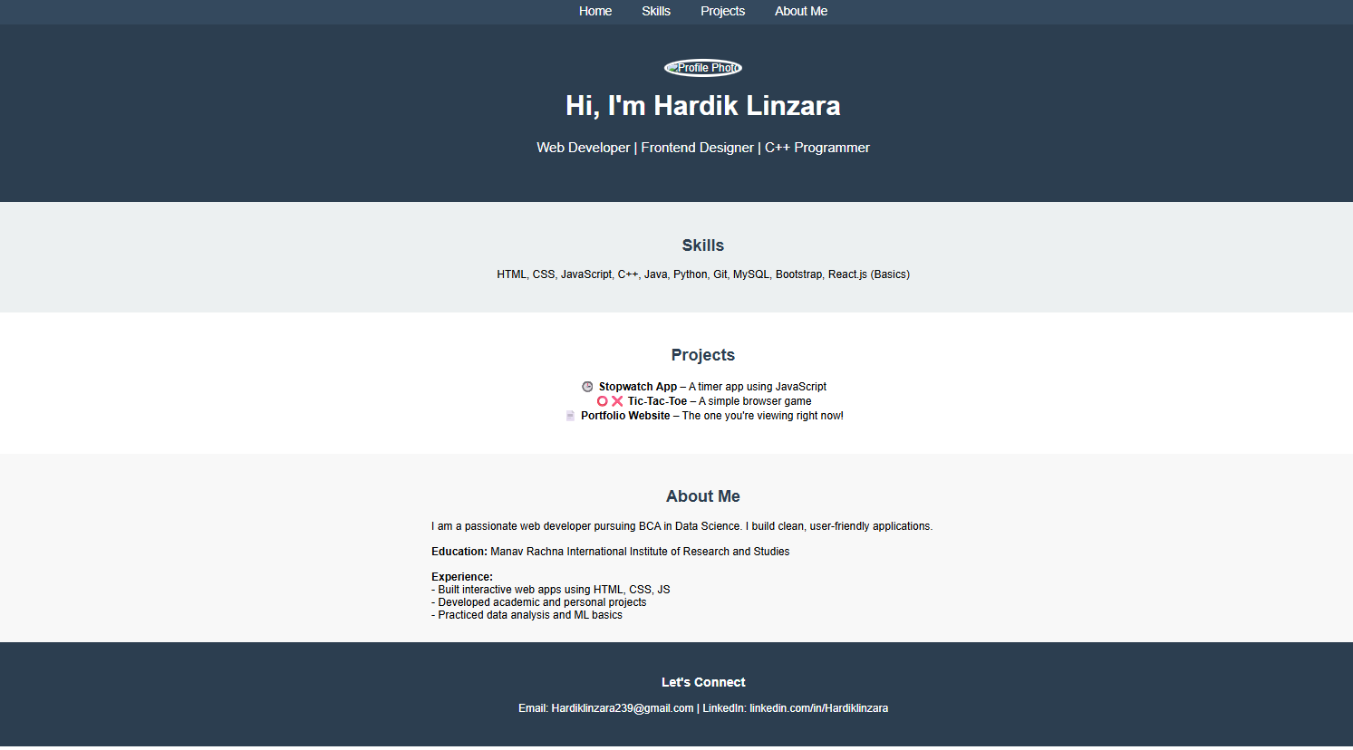

📚 References
- W3Schools: Layout and Media Queries
- CSS Zen Garden
- GitHub: Portfolio samples and inspiration

🌦️ Project 5: Weather App

🔍 Objective
To build a web application that fetches and displays real-time weather data for user-inputted or auto-detected locations using API integration.

🛠 Technologies Used
- HTML
- CSS
- JavaScript
- OpenWeatherMap API

💡 Key Contributions
- Integrated OpenWeatherMap API for data fetching based on city name or location
- Developed intuitive input forms and result display sections
- Styled weather cards with icons and gradients based on weather conditions
- Implemented error handling for invalid inputs and API failures

⚔️ Challenges Faced
- Parsing and converting JSON API responses into usable UI elements
- Managing asynchronous calls and updating the interface reliably
- Ensuring location accuracy and responsive layout across devices

🎯 Outcomes
- Built a visually engaging and informative weather dashboard
- Enabled real-time temperature, condition, and location display
- Applied API-driven development to enhance user experience

🔧 Skills Developed

📟 Technical Skills
- RESTful API integration using JavaScript fetch()
- Data formatting and real-time DOM updates
- Error handling in asynchronous JavaScript functions

🗣️ Soft Skills
- Problem-solving in real-time data environments
- Interpreting user feedback for usability improvements

🤝 Teamwork and Collaboration
- Peer testing for UX and bug fixes
- Mentor guidance for API best practices and data handling

📝 Conclusion

🧭 Summary of Internship Experience
This final project was a culmination of design, logic, and third-party service integration. It pushed me to work with dynamic data and present it cleanly.

✍️ Personal Reflections
Watching live weather data unfold on a page I coded was deeply satisfying. I learned the real-world applications of APIs and how they elevate a user’s experience.

🌟 Future Aspirations

I'd love to expand this app with multi-day forecasts, user preferences, and maybe real-time radar maps using advanced APIs and frameworks.

📎 Appendices

💬 Code Snippets

javascript
fetch(`https://api.openweathermap.org/data/2.5/weather?q=${city}&appid=API_KEY`)
.then(response => response.json())
.then(data => updateWeatherUI(data));
html
<input type="text" id="city-input" placeholder="Enter city name">
<button onclick="getWeather()">Get Weather</button>

📈 Diagrams

Flowchart: User Input → API Call → Parse Response → Display Weather Data
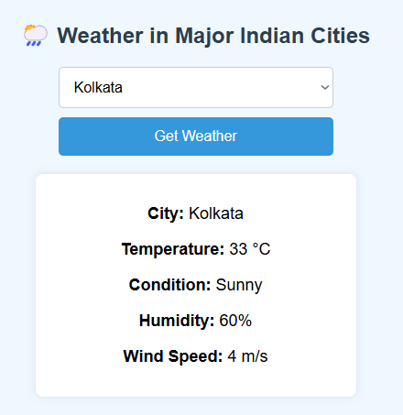

📚 References
- OpenWeatherMap API Docs
- JavaScript.info: Promises and Async/Await
- W3Schools: HTML Forms & CSS Cards

📚 Bibliography
- Mozilla Developer Network

- W3Schools

- CSS Tricks

- JavaScript.info

- OpenWeatherMap API

- Prodigy Infotech learning material

